

Asset Practice Answers: Science

**1. Shown here is a symbol for North direction.**



**Rahul has pasted a map in his book but it is pasted sideways. He knows that Srinagar was to the North of India. How should he draw the symbol on the map?**

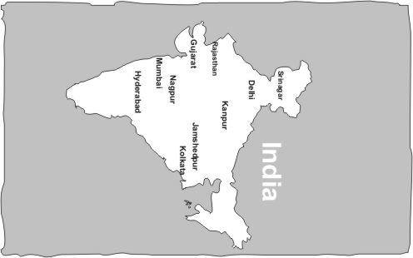

**A.  B. **

**C. D.**

**Correct answer: D**

**2. X, Y and Z are three wooden blocks. Z is the HEAVIEST block. When X and Y are put on a scale with a**

**10 gram weight on the other side, it looks as below.**

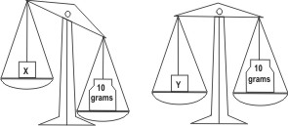

**How will the scale look when block Z is put on the scale with a 10 gram weight?**

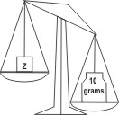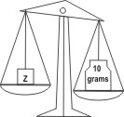**A. 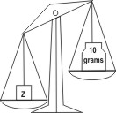 B.** 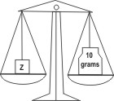

**C. D.**

**Right answer: A**

**3. Shalu went to a park. There were three slides made of the same material.**

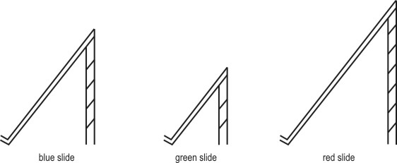

**Shalu climbs up and slides down all the slides, one after the other. On which slide will she take the MOST time to slide down?**

**A. The red slide**

**B.** The blue slide **C.** The green slide

**D.** She will take the same time on all the three slides

**4. Shown here are two types of balls. The black ball is HEAVIER than the grey ball.**



**Mansi had 4 such balls ⎯ 2 black balls and 2 grey balls.**



**Asha also had four balls. But she said that the weight of her 4 balls was more than that of Mansi's balls. Which of these could be Asha's balls?**

**A. 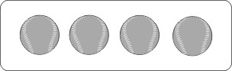 B. 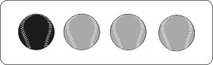 C. 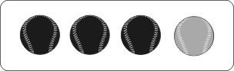 D.** 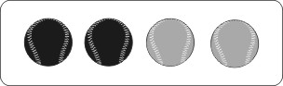

**Right answer: C**

**5. Rama wants to take the children of her class for mountain climbing near their city. To decide on**

**which day to take them, she looks at the weather news in the newspaper. The weather news describes**

**how the weather conditions are most likely to be. Shown below are the weather conditions from**

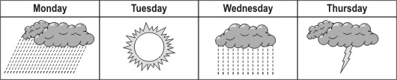**Monday to Thursday.**

**Based on this weather report, which day would be the BEST to go for mountain climbing? A.** Monday

**B. Tuesday**

**C.** Wednesday

**D.** Thursday

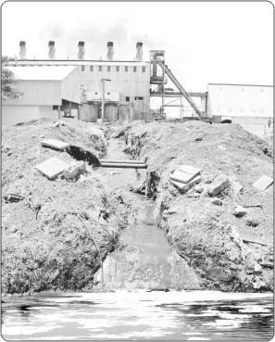

**6.**

**What is this picture showing?**

**A. Pollution of water**

**B.** Wastage of electricity

**C.** Shortage of drinking water

**D.** Construction work in a village

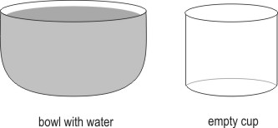**7. Shown here is a bowl full of water and an empty cup.**

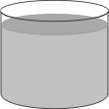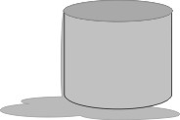**If all the water from the bowl is poured into the cup, what will it look like? A. 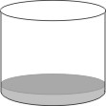 B.** 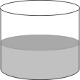

**C. D.**

**Correct answer: D**

**8. In Lily's village, many people use fire wood to cook their food. Lily wants her mother to use a solar cooker which cooks food using the heat of the Sun.**

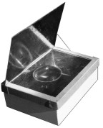

**What could be an advantage of using such a cooker? A.** It makes the food saltier.

**B.** The food will not get burnt.

**C. Smoke will not be given out.**

**D.** Cooking can be done whenever one wants.

**9. Here is a photograph of Arjun's sister. She is a 10-month-old baby and has no teeth.**



**Which of the following will she be able to eat easily? A.** Peanuts

**B.** Sugarcane pieces

**C.** Slices of raw carrot

**D. Paste of ripe bananas**

**10. Maulik had 4 different idols of Lord Ganesha, made of the following materials:**

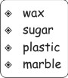  
**He kept each idol in a separate bucket of cold water and left them there for a whole night. In the morning, when he checks them, the idol made of which of these materials would have lost its shape?**

**A.** The wax one

**B.** **The sugar one**

**C.** The plastic one

**D.** The marble one

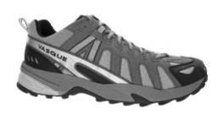**11. Maulik was wearing the following shoes and walking.**

**When he stepped on a surface, it looked like this from the side. What kind of surface was he walking on?**

**A.** A rocky park

**B.** A marble floor **C. A sandy beach**

**D.** A wooden bench

**12. There are some living creatures that spend summer in one country and winter in another country far away. Which of these could be one such living creature?**

**A. 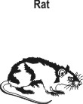 B.** 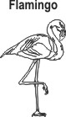

**C. 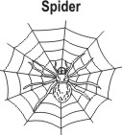 D.** 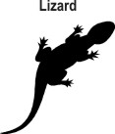

**Correct answer: B**



**Science**

1. D: Did you notice that the map of India is tilted? And so if we have to put the symbol showing the north direction, even that should be tilted. If the map was not tilted, we could have stuck the symbol as shown. But since the map has been tilted to the right, the symbol should also be tilted right and will look like D. If the symbol in B is drawn, it would show Srinagar to the east. Is that correct? Which symbol will show that Srinagar is in north in the tilted map? Only option D will show this.

2. A: It is given that Z is the heaviest block. So its weight is more than that of X as well as Y. As shown in the figure, weight of Y is equal to 10 grams. So it has to be more than 10 grams. This is shown in option A. Option C cannot be correct because in C, the weight of Z is shown to be less than 10 grams.

3. A: Shalu will take the most time to slide down the slide which is the longest. The red slide is the longest and so she will take the most time to slide down it.

4. C: We know that the weight of the black ball is more than that of the grey ball. Mansi has 2 black balls and 2 grey

balls.

Asha has 4 balls and the weight of those 4 balls is more than that of Mansi's balls. So she must have more black balls

than Mansi. The only option that has more than 2 black balls is C. It cannot be D because the balls are the same as those of Mansi's.

5. B: Since it is mountain climbing, which is done in the open, it is better that Rama takes her students on a day when it is not going to rain. As seen in the figure, Tuesday is the day when no clouds or rain are predicted. She should take the students out for mountain climbing on Tuesday.

6. A: The picture shows dirty water flowing into a body of water. The water also seems to be coming from a factory. We can also see white foam in the body of water. This means that the water is most probably dirty. So, option A is the correct answer. The picture does not show construction work in a village. Hence, option D is incorrect.

7. D: Look at the size of the bowl and the cup. They are of the same height. But the bowl is much wider than the cup. Also, the bowl is almost completely full. If we pour all this water into the cup, it will spill out because the water in the bowl is much more than can be filled in the cup. So, only option D is correct. Try this at home with such vessels.

8. C: A solar cooker uses the heat from sunlight to cook. Smoke will not be given out because a fuel like firewood or kerosene is not used. A solar cooker cannot be used once the Sun has set, so cooking cannot be done whenever one wants. Thus, option D is incorrect. Food can get burnt and it will not make food saltier. So, option C is the only correct answer.

9. D: A baby has no teeth, so it needs to eat very soft food. A baby will not be able to eat peanuts, sugarcane pieces or raw carrot easily. But, a baby can eat a paste of ripe bananas because it is soft. So, only option D is correct.

10. B: Try doing this, take a piece each of wax, sugar, plastic and marble. Keep them all in a mug of cold water for the entire night. Check in the morning to see which piece has lost its shape. Only the sugar cube would have lost its shape. This is because sugar can get mixed in water, but wax, plastic and marble cannot. Thus, option B is the correct answer.

11. C: Try doing this! Use your hand and press it down on a rock, a marble floor, a sandy place and a wooden bench. Where will your hand form a pattern by pressing the surface down? Only in the sand! So, option C is the only correct answer.

12. B: Many animals spend summer in one country and winter in another country. Usually, birds are such animals. This is because birds can easily fly to a far-away country. But, other animals find this hard to do. Rats, spiders and lizards do not travel this way. The bird shown in the question, a flamingo, travels from one part of the world to another during different seasons. Hence, option B is the correct answer.